**Information System Management Lab**

**BCOM 307**

**Assignment #18**

***Submitted by:***

**Name:** YASH JAIN

**Enrollment No:** 03914788818

**Semester:** B.Com(H) 5th Semester

**Class:** B.COM(H)

**Section:** B.Com 5A

**Date of Submission:** 18/10/2021

***Submitted to:***

**Praveen Kumar Singh**

**Assistant Professor, MAIMS**



**Department of Commerce**

**Maharaja Agrasen Institute of Management Studies**

**Affiliated to Guru Gobind Singh Indraprastha University, Delhi**

**Sector -22, Rohini, Delhi -110086, India; www.maims.ac.in**

Maharaja Agrasen Institute of Management Studies

Affiliated to GGS IP University; Recognized u/s 2(f) of UGC Recognized by Bar Council ofIndia; ISO 9001: 2015

Certified Institution Sector 22, Rohini, Delhi -110086, India; [www.maims.ac.in](http://www.maims.ac.in/)

Department of Commerce

Academic Year: 2020-21

Semester: Vth

# Assignment No. 18

# Unit No:

**Course/Subject Code:** BCOM 307 **Subject Title: Information System Management Lab**

# Issue Date Last Date of Submission:

**Instructions for Students:**

# All Questions are Compulsory.

1. The student should attach proper cover page for each assignment clearly mentioning the Assignment No.
2. Each assignment should be prepared by the student individually with proper explaination and screenshots.
3. A4 size ruled sheets should be used for the assignment.
4. Assignment pages should be serially numbered at the bottom of page.

***During online education mode, upload scanned copy of the complete assignment including cover page latest by due date.***

|  |  |  |
| --- | --- | --- |
| **Question No.** | **Question** | **CO No.** |
| 1 | To display average salary of each department. | **CO1, CO2, CO3, CO4** |
| 2 | To count the number of employees in each department where salary is more than 2000. |
| 3 | To display name of employees whose hire date is more than 1 Jan 1960. |
| 4 | To display name of employees whose second character is 'l'. |
| 5 | To display average salary of employees table. |

**ASSIGNMENT 18 - GROUP BY and HAVING Clause II**

**Task 1 : To display average salary of each department.**

This task can be completed using the **AVG( )** aggregate function, and the **GROUP BY** clause.

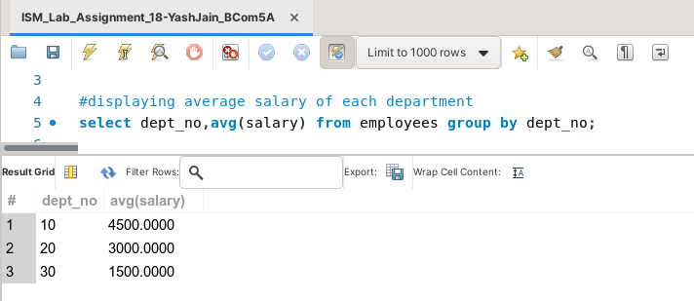

**Task 2: Display the number of clients in each designation.**

This task can be completed using the **GROUP BY** clause, the **WHERE** clause and the **COUNT( )** aggregate function.

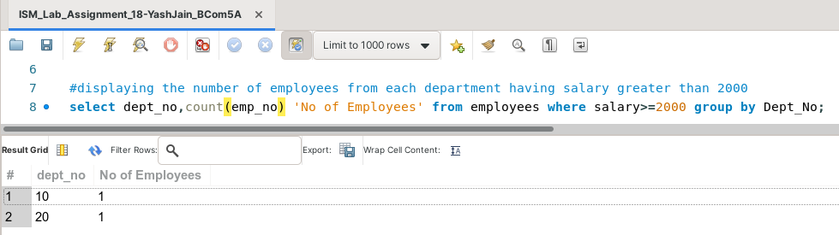

**Task 3: To display name of employees whose hire date is more than 1 Jan 1960.**

This task can be completed using the **WHERE** clause.

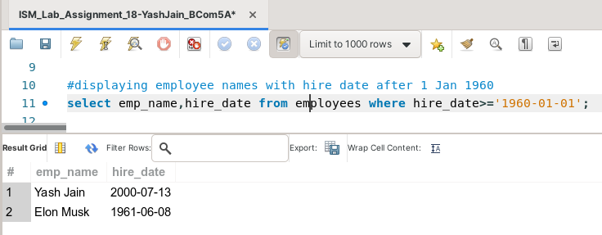

**Task 4: To display name of employees whose second character is 'l'**

This task can be completed using the **LIKE** operator, along with the **WHERE** clause.

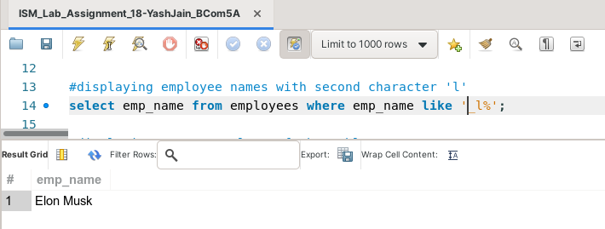

**Task 5: Display average salary of employees table.**

This task can be completed using the **AVG( )** aggregate function.

